P234 程序练习 2.

源代码：

#include<iostream>

#include<cstring>

using namespace std;

class student{

public:

student(char \*s,int x,int y):id(x),score(y){

strcpy(name,s);

}

void input(){

cout<<"name?";

cin>>name;

cout<<"id?";

cin>>id;

cout<<"score?";

cin>>score;

}

void output(){

cout<<"name:"<<name<<"\tid:"<<id<<"\tscore:"<<score<<endl;

}

private:

char name[20];

unsigned int id;

double score;

};

int main(){

student s=student("\0",0,0);

s.input();

s.output();

}

运行截图：

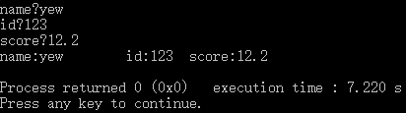

P242 1.

源代码：

#include<iostream>

#include<cstring>

using namespace std;

class Book{

public:

Book(char \*s):price(0),number(0){

strcpy(bookname,s);

}

void display(){

cout<<"书名："<<bookname<<endl;

cout<<"价格："<<price<<endl;

cout<<"存书数量："<<number<<endl;

cout<<endl;

}

void borrow(){

if(number){--number;cout<<"借阅成功！"<<endl;cout<<"当前存书数量："<<number<<endl;}

else cout<<"当前存书数量为0，不可借阅！"<<endl;

cout<<endl;

}

void restore(){

cout<<"还书成功！"<<endl;

++number;cout<<"当前存书数量："<<number<<endl;

cout<<endl;

}

private:

char bookname[100];

int price,number;

};

int main(){

Book book=Book("The Book");

book.display();

book.borrow();

for(int i=0;i<5;++i)book.restore();

book.display();

book.borrow();

book.display();

}

运行截图：

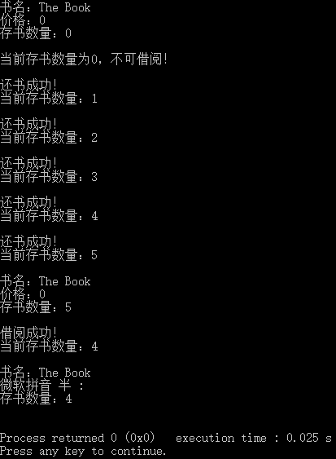

P242 3.

源代码：

#include<iostream>

#include<cstring>

using namespace std;

class student{

public:

void scoretotalcount(double s){

score=s;

student::total+=s;

++count;

}

static double sum(){

return total;

}

static double average(){

return total/count;

}

private:

double score;

static double total;

static int count;

};

double student::total=0;

int student::count=0;

int main(){

int n;student s[100];

cout<<"输入班中同学数量：";

cin>>n;

for(int i=0;i<n;++i){

double temp;

cout<<"输入第"<<i+1<<"位同学的成绩：";

cin>>temp;

s[i].scoretotalcount(temp);

}

cout<<"总分："<<student::sum()<<endl<<"平均分："<<student::average()<<endl;

}

运行截图：

